
A 10
SET NO : 1

Sreenidhi Institute of Science & Technology
(An Autonomous Institution)
Code No: 101ME03/111ME03

B. TECH. I – Year II – Semester Examinations, June/July, 2012 (Regular/Suppli)
ENGINEERING MECHANICS (ME)

Time: 3 Hours Max. Marks : 70

Note : No additional answer sheets will be provided.

Part-A (Objective Type)
Max.Marks:20

Answer all QUESTIONS.

1. Define moment of a force and mention its applications.

2. State the conditions of equilibrium.

3. Define the terms angle of friction and cone of friction.

4. What is wedge friction? Mention its applications.

5. Sate the assumptions made in the analysis of trusses.
6. Distinguish between method of joints and method of sections.

7. Distinguish between centroid and centre of gravity.

8. State theorems of Pappus and Guildinus.

9. Define parallel and perpendicular axis theorems.

10. State work – Energy method.

Part – B
Max. Marks: 50

ANSWER ANY FIVE QUESTIONS. EACH QUESTION CARRIES 10 MARKS.

1. Determine the resultant of the four forces and a couple that acts on the plate shown
Figure 1.
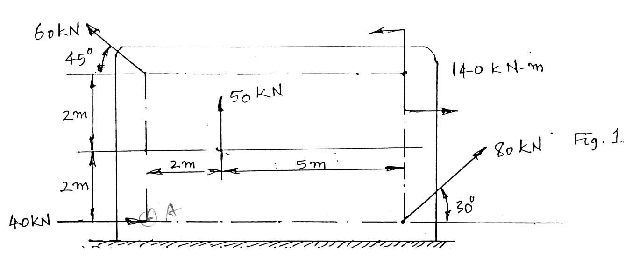
2. Two identical rollers, each of weight W =1000N, are supported by an inclined plane and a vertical wall as shown in Figure 2. Find the reactions at the points of supports A, B and C. Assume all the surfaces to be smooth.
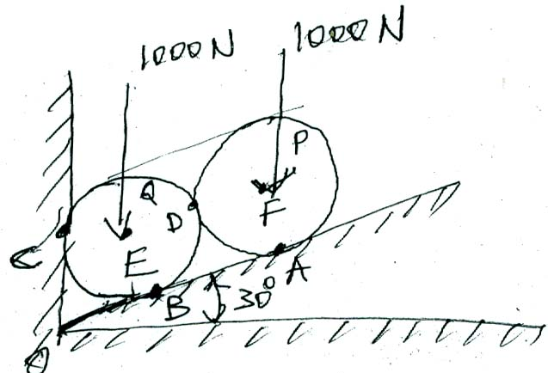
3. The three blocks with weights as shown in Figure 3 are placed on a 20⁰ incline so that they are in contact with each other and at rest. Determine which, if any, of the blocks will move and the friction force acting under each. Assume that under blocks A and C, the coefficients of friction are μ_{s} = 0.50 and μ_{k} = 0.40 while under B they are μ_{s} = 0.3 and mk0.20.
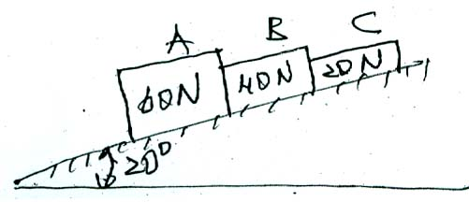
4. Find the forces in all the members of the truss shown in Fig 4.
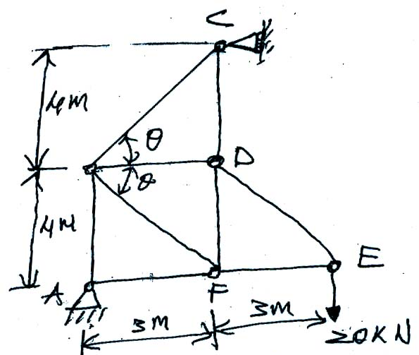
5. a). Determine the centroid of the area between parabola x² = ay and straight
line y = x as shown in Figure 5.
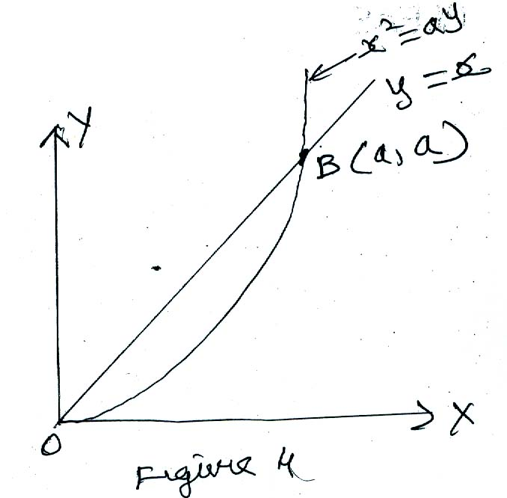
b). A right circular cylindrical tank containing water spins about its vertical geometric axis, as shown in Figure 6, at such speed that the free water surface is a paraboloid AOB. What will be the depth of water in the tank when it comes to rest ?
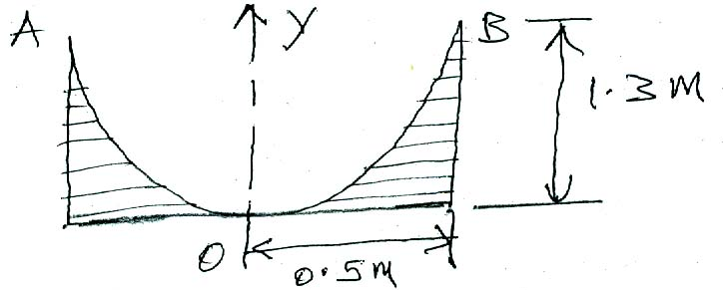
6. a). Compute the moment of inertia of the 100 mm X 150 mm rectangle shown
in Fig 7. about the X axis to which it is inclined at an angle θ = sin⁻¹  .
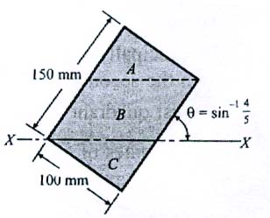

b). Determine the second moment of the shaded area under the curve y = kx^{n}, as shown in Fig 8, with respect to specified X - and Y – axis.
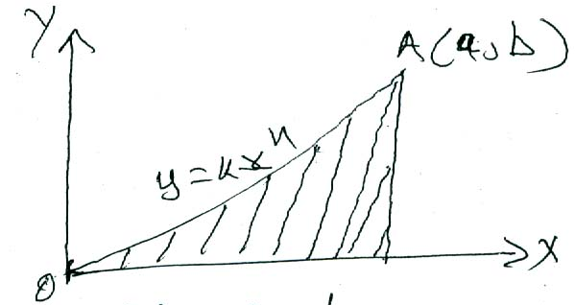

7. Determine the mass moment of inertia of a solid right circular cone of base radius R and height h with respect to its geometric axis of rotation.

8. A solid cylinder and a homogeneous sphere, each of weight W and radius r, roll without slipping down a plane inclined at θ⁰ with the horizontal. For each body, determine the minimum coefficient of friction to prevent slipping and the acceleration of the mass center.

-- 00 -- 00 --

